|  |  |
| --- | --- |
|  | **2016** |
|  | Citizen Information Group  Kelly, Justin |

|  |
| --- |
| **[Operational Document**  **Advanced Warfighter]** |
| This document provides the overview regarding the Advanced Warfighter video game, command and control software system and the various sub systems. This is a living document that is continually updated as the software develops. |

Table of Contents

About the Citizen Information Group 2

Overview 3

Executive overview 3

Overview 3

Gameplay Goals 3

Business Goals 3

Advance Warfighter in Detail 4

# About the Citizen Information Group

Founded in 2015, The Citizen Information Group (CIG) is a modern Information company founded to promote civil interests, social services and change. Built to promote Canadian values and to: respond to, capitalize on, and influence the coming era of interconnected devices. CIG aims to be on the forefront of the Online to Offline shift, Interactive urbanization (smart cities) and personalization/tailoring of data of services and governance.

The Citizen Information group at the highest level is an information company. It is though data collection, mining, analysis, control and monetization of business intelligence that we generate revenue. This revenue provides the money to sustain nonprofit social services and programs, well as other humanitarian initiatives. It is though these initiatives the CIG provides it social services.

Though outreach Initiatives the CIG provides a spectrum of social services that enhance the communities we operate in.

For businesses (our main clients) we provide and all inclusive service of accurate customer profiling, customer retention and easy system for creating loyalty cards and rewarding customers.

For customers we provide a host of at-cost social services based off of membership and loyalty to the CIG Company. Using funding from customers routine life, customers are rewarded and provided with enhanced ease of life. As companies that comply with the CIG infrastructure get added in, the user gains more solutions to day-to-day problems, though the simple web interface.

Some services we provide:

* The Citizen Card – The membership card and key tracking tool for the member base. Provides the access point for social services and rewards
* Advance Warfighter Game – A revenue, information and member engagement generating tool based around a worldwide 2D strategy game.
* Report-It! – A global reporting system that allows for direct communication of praise and problems to Police, Bylaw, Governmental and Private businesses
* Emergency.ca – A centralized system for citizenry to preparing for, requesting help and providing help during major disasters.
* Rideshare – Approved and verified transportation listings
* Me-Cycle – Accredited valuable goods removal
* Eventspace – Provides temporary (day/hour) rental of spaces for events
* FeedMe – Grocery (Goods) delivery

Advanced Warfighter

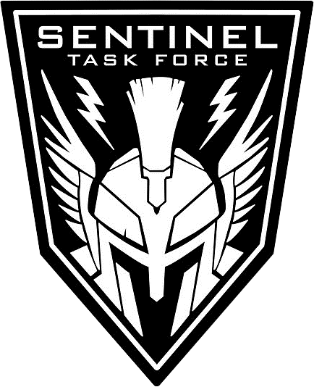

# Overview

## Executive overview

Advanced Warfighter is realistic, 1500 vs. 1500 unit, 2D top down strategy game, which is played in the real world as well as online. AWF utilizes a live community maintained world map that is played on 24/7 with nations fighting for supremacy. Desktop focused with heavy mobile interaction. Pla

## Overview

Advanced Warfighter is realistic 2D top down strategy game that uses a living and community maintained global world map. The game is played in the real world as well as online. Where teams of 1500 units compete online and offline for control of territory worldwide.

Using the latest in global positioning, social and geographic information technology. Players play around the clock fighting on a street by street level, to nation state level, for their respective nationalities and home cities.

AWF integrates social engineering, direct selling and a reward structure for local businesses and players. Players are rewarded for visiting local establishments and making purchases. Territory rewards the user with additional bonuses and real world rewards.

## Gameplay Goals

To provide an engaging game platform that gives the users a scalable experience from of being everything from a squad leader, to a general in a theater of war. An online experience that blurs the lines between offline and online and takes advantage of the coming age of interconnected devices. Users will be able to great grand armies of players and compete in massive never before seen battles, such as weeklong or even month long sieges of major cities. The game will feel living and alive, a parallel world to our own, with ever increasing interaction and effect from the real world.

## Business Goals

To provide an engaging game platform that generates revenue and information for future endeavors of the Citizen Information Group. The game serves as a focal point and launch pad for early Citizen user accounts. The game will inspire people to maintain city maps, provide geo location data and to become active in their community.

Most importantly development of this game will provide the bed rock of the CIG Company. The game will a platform and proof of concept, thus power, for future business deals and advertisements as well as revenue to achieve social programs.

# Advance Warfighter in Detail

## Teams

Team size is 1500 vs 1500 units. Of this it is expected that 100, or less, per side may be human/non AI controlled.

The teams are divided by nationality and geo location.

In game Teams are summarized as “Us vs Them and Them” and regardless of country of origin your UI remains the same.

## Groups

The following groups known to you

* Your Commanded forces
* Friendly – BLUFOR (Blue Forces)
* Hostile – OPFOR/REDFOR (Opposing/Red Forces)
* Nonaffiliated/Rebel/Local, Friendly/Unfriendly – GRNFOR (Green Forces)
* Neutral - Yellow

### BLUFOR

#### Title

Blue Forces

#### Description

BLUFOR is all friendly forces aligned with you. Blue Forces are your countries forces, excluding your forces. You are a member of BLUFOR.

#### Graphical representation

##### Global Map

Blue circles on map

##### Local Map

Blue circles on map

##### Nato Icons

Black Nato Icons

### OPFOR/REDFOR

#### Title

Opposing Forces / Red Forces

#### Description

OPFOR/REDFOR is all hostile forces. Meaning forces that are armed and will attack you on sight.

### GRNFOR

#### Title

Green Forces

#### Description

GRNFOR is all friendly/unfriendly nonaffiliated forces. These forces are normally local, rebel or insurgent civilian forces. These forces are Not affiliated with any major army. They mostly armed and will not intentionally attack on sight, but may treat you poorly or be unfriendly towards you. GRNFOR can become hostile forces without warning. GRNFOR are likely in conflict with other GRNFOR forces.

### NEUFOR

#### Title

Neutral Forces

#### Description

NEUFOR is for all official neutral forces. These forces are non-combative and are very unlikely to engage any forces. Most commonly applied to civilian populations, Foreign humanitarian forces and neutral country forces.

METAR CODES

* BLU
* WHT
* GRN
* YLO
* AMB

## Zoom Levels

<http://wiki.openstreetmap.org/wiki/Zoom_levels>

We will maintain the established levels used by OpenStreeMap.

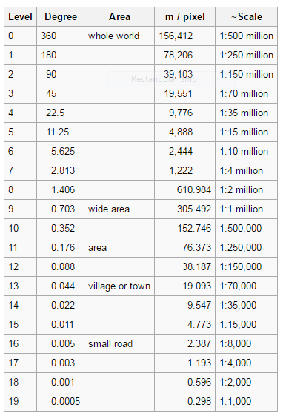

**What is Advanced Warfighter?**

Advanced Warfighter is realistic 2D top down strategy game, set in the near-future.

Large combat groups of 1500 vs. 1500 units

Gameplay plays in the real world as well as online.

AWF utilizes a community maintained world map. This map live and always on, ensuring the freshest known data.

Gameplay is scales from tactical platoon level combat, to theater level operations.

Logistics and Production is simplified, modeled and a gameplay component.

Nations are pitted against each other for supremacy.

Developed for Web/Browser and serious PC gaming.

There is deep mobile component that promotes the real world interaction.

Real world interaction will tie into sister projects within the Information Group.